RESEARCH ARTICLE

Comparative Physicochemical and Ultrastructural Characterization of Urinary Extracellular Vesicle-Enriched and Honey Vesicle-Like Nanoparticle Preparations
Agus Limanto^{6*}, Glen Marchelinno Souissa¹, Bryan Christopher Wiraputra¹, Deby Deby², Purnamawati², Eden Steven³, Yudhi Nugraha⁴, Ahmad Novi Muslimin⁵
1 School of Medicine, Faculty of Medicine and Health Sciences, Krida Wacana Christian University, West Jakarta, 11510, Indonesia
2 Department of Histopathology and Anatomy, Faculty of Medicine and Health Sciences, Krida Wacana Christian University, West Jakarta, 11510, Indonesia
3 Emmerich Research Center, North Jakarta, 14450, Indonesia
4 Eijkman Research Center for Molecular Biology, National Research and Innovation Agency (BRIN), Cibinong, Bogor, 16911, Indonesia
5 Physics and Advanced Imaging Laboratory, National Research and Innovation Agency (BRIN), Cibinong, Bogor, 16911, Indonesia
6 Department of Biochemistry and Biomolecular, Faculty of Medicine and Health Sciences, Krida Wacana Christian University, West Jakarta, 11510, Indonesia
*Corresponding author: Agus Limanto; agus.limanto@ukrida.ac.id; telephone: +62 817 6777 781; Department of Biochemistry and Biomolecular, Faculty of Medicine and Health Sciences, Krida Wacana Christian University, West Jakarta 11510, Indonesia.
Author email addresses and ORCID IDs:
Agus Limanto: agus.limanto@ukrida.ac.id; https://orcid.org/0000-0002-6037-1271
Glen Marchelinno Souissa: glenn.102022151@civitas.ukrida.ac.id; https://orcid.org/0009-0006-1783-1208
Bryan Christopher Wiraputra: bryan.102022052@civitas.ukrida.ac.id; https://orcid.org/0009-0003-8860-3833
Deby Deby: deby.deby@ukrida.ac.id; https://orcid.org/0009-0006-2394-1972
Purnamawati: purnamawati@ukrida.ac.id; https://orcid.org/0000-0002-4804-3785
Eden Steven: eden.steven@gmail.com; https://orcid.org/0000-0003-4591-487X
Yudhi Nugraha: yudhi.nugraha@brin.go.id; https://orcid.org/0000-0003-1186-4093
Ahmad Novi Muslimin: ahmadnovimuslimin20@gmail.com; https://orcid.org/0000-0002-2174-5461

ABSTRACT
Background: Extracellular vesicle (EV)-enriched preparations from human urine and vesicle-like nanoparticles from honey are accessible matrices for biomolecular and nanobiology research, but direct cross-matrix characterization remains limited.
Methods: Urine from three healthy donors and three independent batches of wild forest honey were processed separately by source and donor/batch using differential centrifugation, 0.22 µm filtration, and ultracentrifugation at 100,000 × g. Preparations were pooled within each source only after isolation. Preparations were characterized by dynamic light scattering (DLS), apparent zeta potential, Bradford total-protein assay, exploratory bead-based anti-human CD9/CD81 flow cytometry, and cryoelectron microscopy (cryo-EM).
Results: Urine preparations showed DLS Z-average values of 111.9-324.9 nm, whereas honey preparations showed 211.3-614.1 nm, indicating marked intensity-weighted heterogeneity. Apparent zeta potentials measured in high-conductivity phosphate-buffered saline were approximately +0.1 mV for urine and -3.0 to -1.6 mV for honey and were considered buffer-limited. Total protein concentrations were 187.7 µg/mL for urine and 181.6 µg/mL for honey. Anti-human CD81-positive bead events were 20.0% in urine and 0.3% in honey; the human assay is not validated for honey-derived particles. Cryo-EM demonstrated membrane-enclosed vesicular structures in both matrices.
Conclusion: The two preparations showed distinct physicochemical profiles and matrix-dependent analytical limitations. These findings provide a descriptive baseline and support the need for particle-number measurements, broader marker panels, and source-appropriate assays before biological or therapeutic inferences are made.
Keywords: cryo-electron microscopy; extracellular vesicles; honey; nanoparticles; ultracentrifugation; urine

INTRODUCTION
Extracellular vesicles (EVs) are membrane-enclosed particles released by cells and recovered from many biological fluids. Because physical separation procedures also recover non-vesicular particles and soluble macromolecules, current international guidance recommends operational terminology and orthogonal characterization rather than assigning a biogenesis-based EV subtype when biogenesis has not been demonstrated (1,2). This distinction is especially important when complex matrices are compared using a common enrichment workflow.
Urine is a non-invasive source of human EV-associated material and is increasingly studied for biomarker discovery (3-7), but urinary EV measurements are sensitive to collection, dilution, uromodulin, storage, and isolation procedures (6,8-10). Honey is biologically and physicochemically distinct from human biofluids. Vesicle-like nanoparticles have been reported in honey and other bee products, with membrane-associated cargo and biological activities described in prior studies (11-17). Human tetraspanin assays, however, cannot be assumed to validate particles from honey because their epitope specificity is source dependent.
Direct, matrix-aware comparison of urinary EV-enriched and honey vesicle-like nanoparticle preparations remains limited. The present study therefore used the same broad enrichment framework—differential centrifugation, 0.22 µm filtration, and ultracentrifugation—followed by DLS, electrophoretic light scattering, total-protein quantification, exploratory bead-based anti-human CD9/CD81 flow cytometry, and cryo-EM. The objective was descriptive: to define physicochemical and ultrastructural characteristics of the two preparations and identify matrix-specific analytical limitations, without inferring EV purity, particle yield, therapeutic function, or biogenesis.

MATERIALS AND METHODS

Study design and ethical scope
This descriptive laboratory study compared preparations obtained from healthy-donor urine and commercial wild forest honey. The human-subject component was deliberately limited to urine collection, consistent with the scope of the available ethical approval. Urine was collected from three healthy donors after written informed consent. Honey comprised three independent harvest batches and was treated as non-human commercial material. Donor and harvest-batch specimens remained separate during enrichment; the resulting preparations were pooled within each source only after ultracentrifugation.

Urine collection
First-morning midstream urine was collected from healthy donors (n = 3) with no reported kidney or urinary tract disease, active urinary tract infection, pregnancy, or use of nephrotoxic medication. Donors were instructed to avoid strenuous exercise before collection. Samples were collected in sterile polypropylene containers, assessed visually and by routine urine quality measures, and processed promptly. Across donors, 150 mL of urine entered the enrichment workflow.

Honey material
Wild forest honey was obtained from Beezee Honey Indonesia and was produced by the giant honey bee Apis dorsata Fabricius, 1793 in a Central Java conservation forest. Three independent harvest batches (total starting volume, 150 mL) were used. The honey was supplied fresh and unprocessed, transported under cooled and light-protected conditions, and stored at 4 °C before processing.

Enrichment of urine and honey preparations
Low- and medium-speed centrifugation steps were performed using a Velocity 18R Pro refrigerated centrifuge. Ultracentrifugation was carried out using an Optima XPN-100 ultracentrifuge (Beckman Coulter, USA) equipped with an SW-41 Ti swinging-bucket rotor (k-factor 124) and thin-wall polypropylene tubes. Relative centrifugal force is reported as × g.
Urine was sequentially centrifuged at 400 × g for 10 min and 2,000 × g for 15 min at 20 °C. The supernatant was then centrifuged at 10,000 × g for 30 min at 20 °C, passed through a 0.22 µm polyethersulfone membrane filter, and ultracentrifuged at 100,000 × g for 90 min at 4 °C. Pelleted material from each donor was gently resuspended in phosphate-buffered saline (PBS). The donor-derived preparations were pooled after ultracentrifugation, yielding a cumulative final urine-preparation volume of 15 mL.
Honey was diluted 1:20 (v/v) in particle-filtered PBS (pH 7.4) containing protease inhibitor and gently mixed until homogeneous. Clarification comprised 400 × g for 10 min, 2,000 × g for 15 min, and 10,000 × g for 30 min at 20 °C, followed by 0.22 µm polyethersulfone filtration and ultracentrifugation at 100,000 × g for 90 min at 4 °C. Pelleted material from each harvest batch was resuspended in PBS. The batch-derived preparations were pooled after ultracentrifugation, yielding a cumulative final honey-preparation volume of 14 mL. Final suspension volumes are reported only as operational handling volumes and were not interpreted as particle recovery or EV yield.

Particle size and apparent zeta potential
Hydrodynamic size distributions were measured by DLS using a HORIBA nanoPartica SZ-100V2 Series instrument at 25 °C. Samples were diluted in 0.22 µm-filtered PBS and technical runs were recorded for each matrix. The instrument reported intensity-weighted distributions, Z-average hydrodynamic diameter, and polydispersity index (PDI). Because DLS scattering is strongly influenced by larger particles, the Z-average was interpreted as a matrix-level intensity-weighted descriptor rather than a count-based particle-size distribution (2,18-20).
Electrophoretic light scattering was performed on the same instrument at 25 °C. Electrophoretic mobility was converted to zeta potential using the Smoluchowski approximation. Measurements were made in PBS with conductivity of approximately 16 mS/cm. High ionic strength compresses the electrical double layer; therefore, the results are reported as apparent zeta potential and are not interpreted as intrinsic vesicle surface charge.

Total protein quantification
Total protein in the final suspensions was measured by Bradford assay. Bovine serum albumin standards covered 10–160 µg/mL in five concentrations, each measured in technical triplicate. Samples and standards (5–20 µL) were combined with Bradford reagent to a final volume of 200 µL, incubated for 10 min at room temperature, and read at 595 nm using a Bio-Rad iMark microplate spectrophotometer. Sample concentrations were interpolated from the linear standard curve only within its analytical range. Total protein was not used as a surrogate for EV number or purity.

Exploratory bead-based flow cytometry
Tetraspanin-associated signal was explored using the Exosome Isolation and Analysis Kit – Flow Cytometry, Plasma (Abcam, Cambridge, UK; Cat. No. ab267479). Preparations were incubated overnight with 6.5 ± 0.2 µm polystyrene capture beads pre-coupled with anti-human CD9, blocked with the supplied assay buffer, and stained with PE-conjugated anti-human CD81 (clone M38) for 60 min at 2–8 °C. Unstained bead–sample tubes were used to set background. Isotype-matched, bead-only, and detergent-lysis controls were not available and this is treated as an analytical limitation.
Samples were analyzed on a BD FACSCanto II flow cytometer (BD Biosciences, USA) using FACSDiva version 6.1.3. A common sequence was applied: exclusion of debris by forward/side scatter, singlet selection, bead-event identification, and CD81 assessment in the PE channel. CD81-positive values represent percentages of events within the bead gate and not percentages of individual EVs (21). The anti-human kit was adapted to urine and used only exploratorily for honey; it is not validated as an identity assay for honey-derived particles.

Cryo-electron microscopy
Morphology was examined using a 100 kV Tundra Cryo-TEM (Thermo Fisher Scientific). Samples (4 µL) were applied to glow-discharged 200-mesh copper grids with Lacey Formvar/Carbon support film. Grids were blotted in a Vitrobot Mark IV at approximately 4 °C and 100% relative humidity for 6 s at force level 3 and vitrified by plunging into liquid ethane. Representative micrographs were acquired at 180,000× magnification with an electron dose of 18.52 electrons/Å². Cryo-EM was used to document membrane-enclosed structures; it was not used to infer particle concentration, purity, or EV biogenesis (2,22-24).

Data analysis
Analysis was descriptive. Because preparations from individual donors or harvest batches were pooled within each source after ultracentrifugation, downstream characterization was performed at the pooled-matrix level rather than on independent donor- or batch-resolved biological replicates. Technical runs on pooled preparations were not treated as independent biological replicates, and no inferential comparison between urine and honey was performed. Results are presented as observed ranges, concentrations, percentages, or representative instrument outputs as appropriate.

Use of generative AI in manuscript preparation
OpenAI ChatGPT (GPT-5.6 Sol) was used to assist with English-language editing, restructuring the abstract from the supplied research text, numeric citation formatting, and manuscript layout. The tool was not used to conduct experiments or generate measurement data, microscopy images, or research datasets. Scientific content, reference accuracy, and the submitted manuscript remain the responsibility of the authors.

RESULTS

Particle size distribution
DLS demonstrated heterogeneous intensity-weighted particle distributions in both preparations. Urine showed Z-average values from 111.9 to 324.9 nm across available runs; the representative run shown in Figure 1(a) had a Z-average of 162.2 nm and PDI of 0.558. Honey showed Z-average values from 211.3 to 614.1 nm; the representative run shown in Figure 1(b) had a Z-average of 211.3 nm and reported PDI of 1.698. The latter PDI was retained as an instrument output but not used as a reliable quantitative measure of distribution breadth. A small-size intensity mode near 58.3 nm accounted for approximately 22% of the area in one honey run, but DLS intensity weighting prevents interpretation of that area as a particle-number fraction.
Table 1. Dynamic light scattering results for urine and honey preparations
Source | Observed Z-average range (nm) | Interpretation of intensity-weighted profile
Urine | 111.9–324.9 | Heterogeneous; nanoscale and larger intensity contributions
Honey | 211.3–614.1 | Strongly heterogeneous; submicron signal dominated the intensity readout
Z-average values are intensity weighted. DLS does not provide absolute particle concentration and is disproportionately influenced by larger particles.
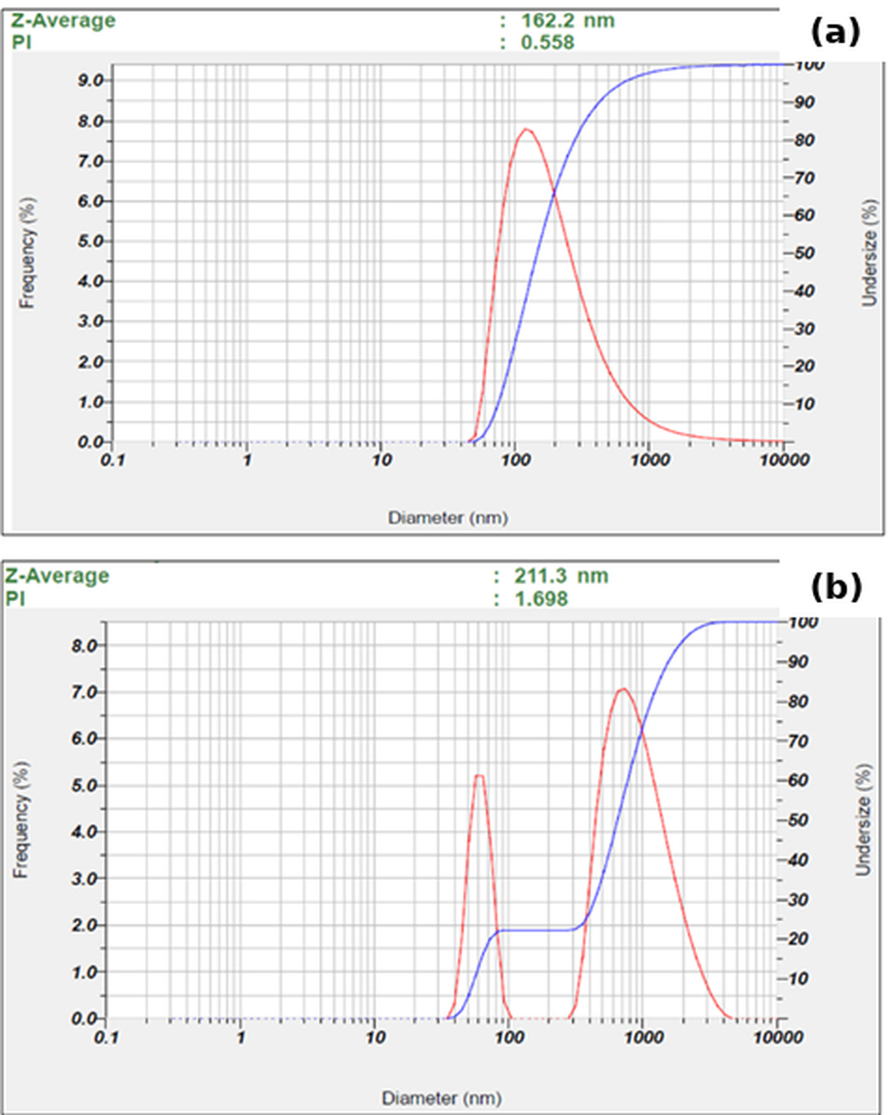
Figure 1. Representative DLS intensity-weighted size distributions of (a) urine-derived EV-enriched and (b) honey-derived vesicle-like nanoparticle preparations. The representative urine run had a Z-average of 162.2 nm and PDI of 0.558; the representative honey run had a Z-average of 211.3 nm and PDI of 1.698.

Apparent zeta potential
The urine preparation showed an apparent zeta potential of approximately +0.1 mV, whereas the honey preparation ranged from −3.0 to −1.6 mV (Table 2; Figure 2). Conductivity was 16.628 mS/cm for the urine measurement and 15.996 mS/cm for honey. Because both measurements were made in high-conductivity PBS, these low-magnitude values were treated as buffer-limited observations rather than intrinsic surface-charge estimates.
Table 2. Apparent zeta-potential measurements
Source | Apparent zeta potential (mV) | Conductivity (mS/cm) | Electrophoretic mobility (cm²/V·s)
Urine | ~+0.1 | 16.628 | approximately 0
Honey | −3.0 to −1.6 | 15.996 | −0.000023 to −0.000013
Measurements were performed in PBS at high conductivity; values should not be interpreted as intrinsic vesicle surface charge.
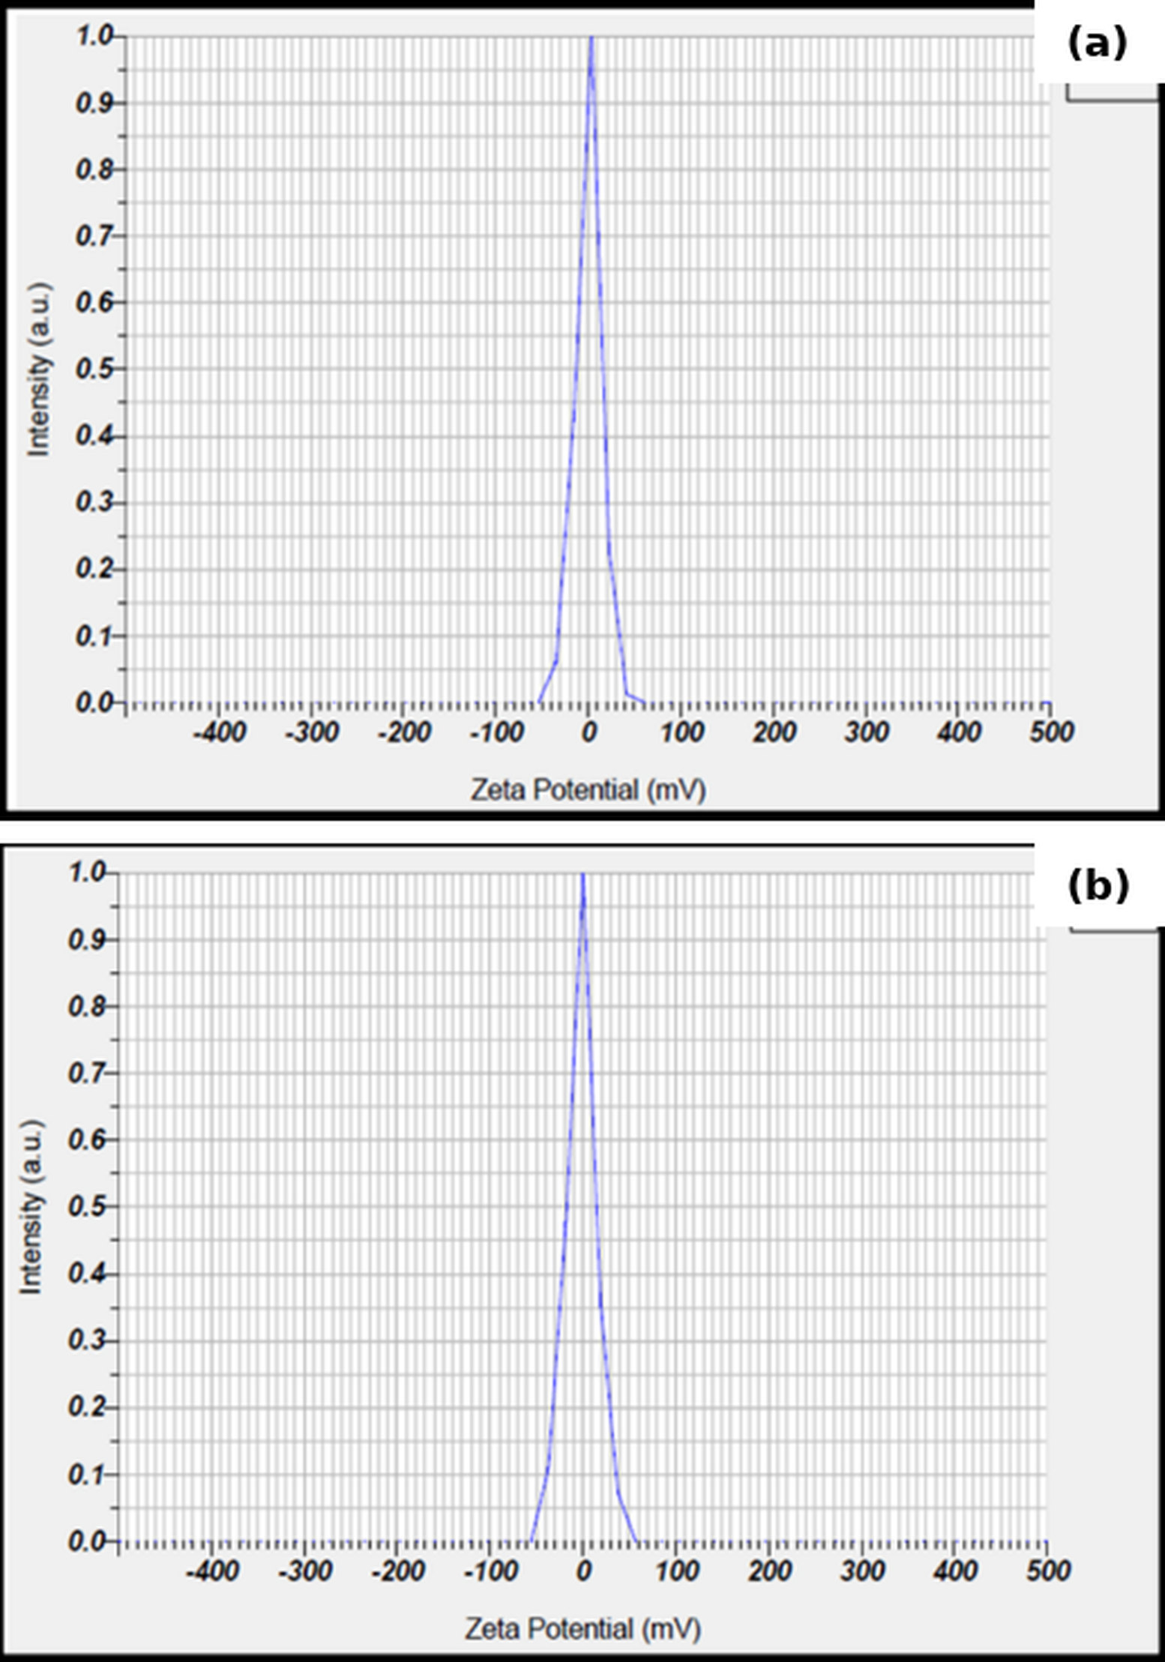
Figure 2. Representative apparent zeta-potential distributions of (a) urine and (b) honey preparations measured by electrophoretic light scattering in PBS. High buffer conductivity limits interpretation of the absolute values.

Total protein
The Bradford standard curve was linear over the working range (y = 0.00193x + 0.0107; R² = 0.989; Figure 3). Total protein concentration in the final suspension was 187.7 µg/mL for urine and 181.6 µg/mL for honey. Based on the cumulative final suspension volumes, this corresponded to 2.82 mg and 2.54 mg total recovered protein, respectively (Table 3). These values quantify protein in the enriched preparations and do not distinguish vesicle-associated protein from co-isolated soluble or non-vesicular protein.
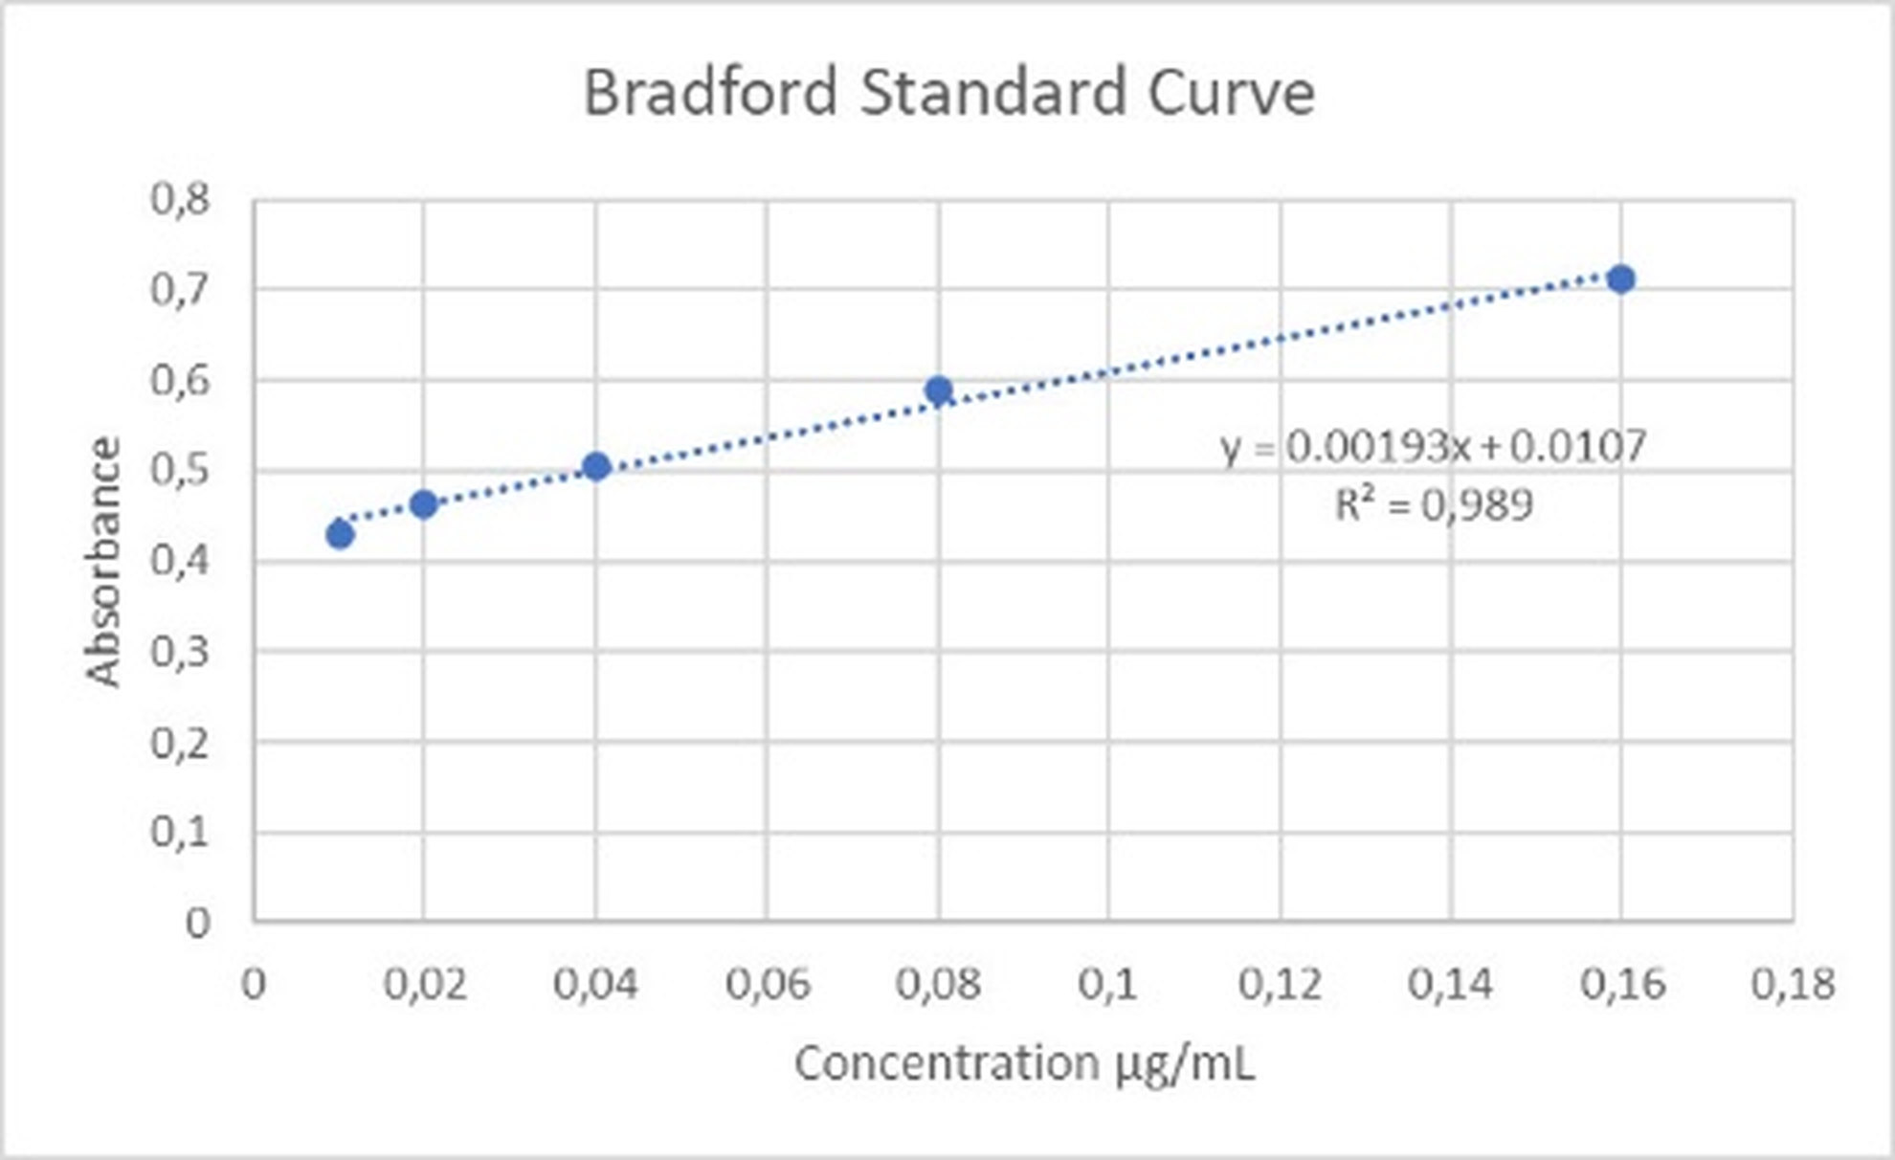
Figure 3. Bovine serum albumin Bradford standard curve used for total-protein quantification (10–160 µg/mL; y = 0.00193x + 0.0107; R² = 0.989).
Table 3. Total protein in urine and honey preparations
Source | Initial volume (mL) | Final suspension volume (mL) | Total protein concentration (µg/mL) | Total recovered protein (mg) | Protein normalized to initial volume (µg/mL)
Urine | 150 | 15 | 187.7 | 2.82 | 18.8
Honey | 150 | 14 | 181.6 | 2.54 | 17.0
Protein values characterize the final enriched suspensions and are not measures of EV particle number or purity.

Anti-human CD81 signal in bead-based flow cytometry
Unstained controls showed low background within the bead gate: 0.1% CD81-positive events for urine and 0.0% for honey. After staining, the urine preparation showed 20.0% CD81-positive bead events by the prespecified dot-plot gate (19.3% by the available histogram gate), whereas honey showed 0.3% by both readouts (Table 4; Figure 4). Upstream singlet and bead gating retained substantial event populations in both matrices.
Table 4. Bead-based flow-cytometry gating and anti-human CD81 signal
Source | Staining | All events (n) | Non-debris (% total) | Singlets (% parent) | Beads (% parent) | CD81-positive beads (% bead gate)
Urine | Unstained | 15,840 | 60.6 | 94.1 | 87.6 | 0.1
Urine | Stained | 72,039 | 48.8 | 95.1 | 79.7 | 20.0
Honey | Unstained | 10,395 | 63.6 | 96.2 | 91.9 | 0.0
Honey | Stained | 38,016 | 56.5 | 95.2 | 85.7 | 0.3
Percentages follow the instrument/software hierarchy. CD81-positive values are percentages of bead-gated events, not percentages of individual EVs. The anti-human CD9/CD81 assay is not validated for honey-derived particles.
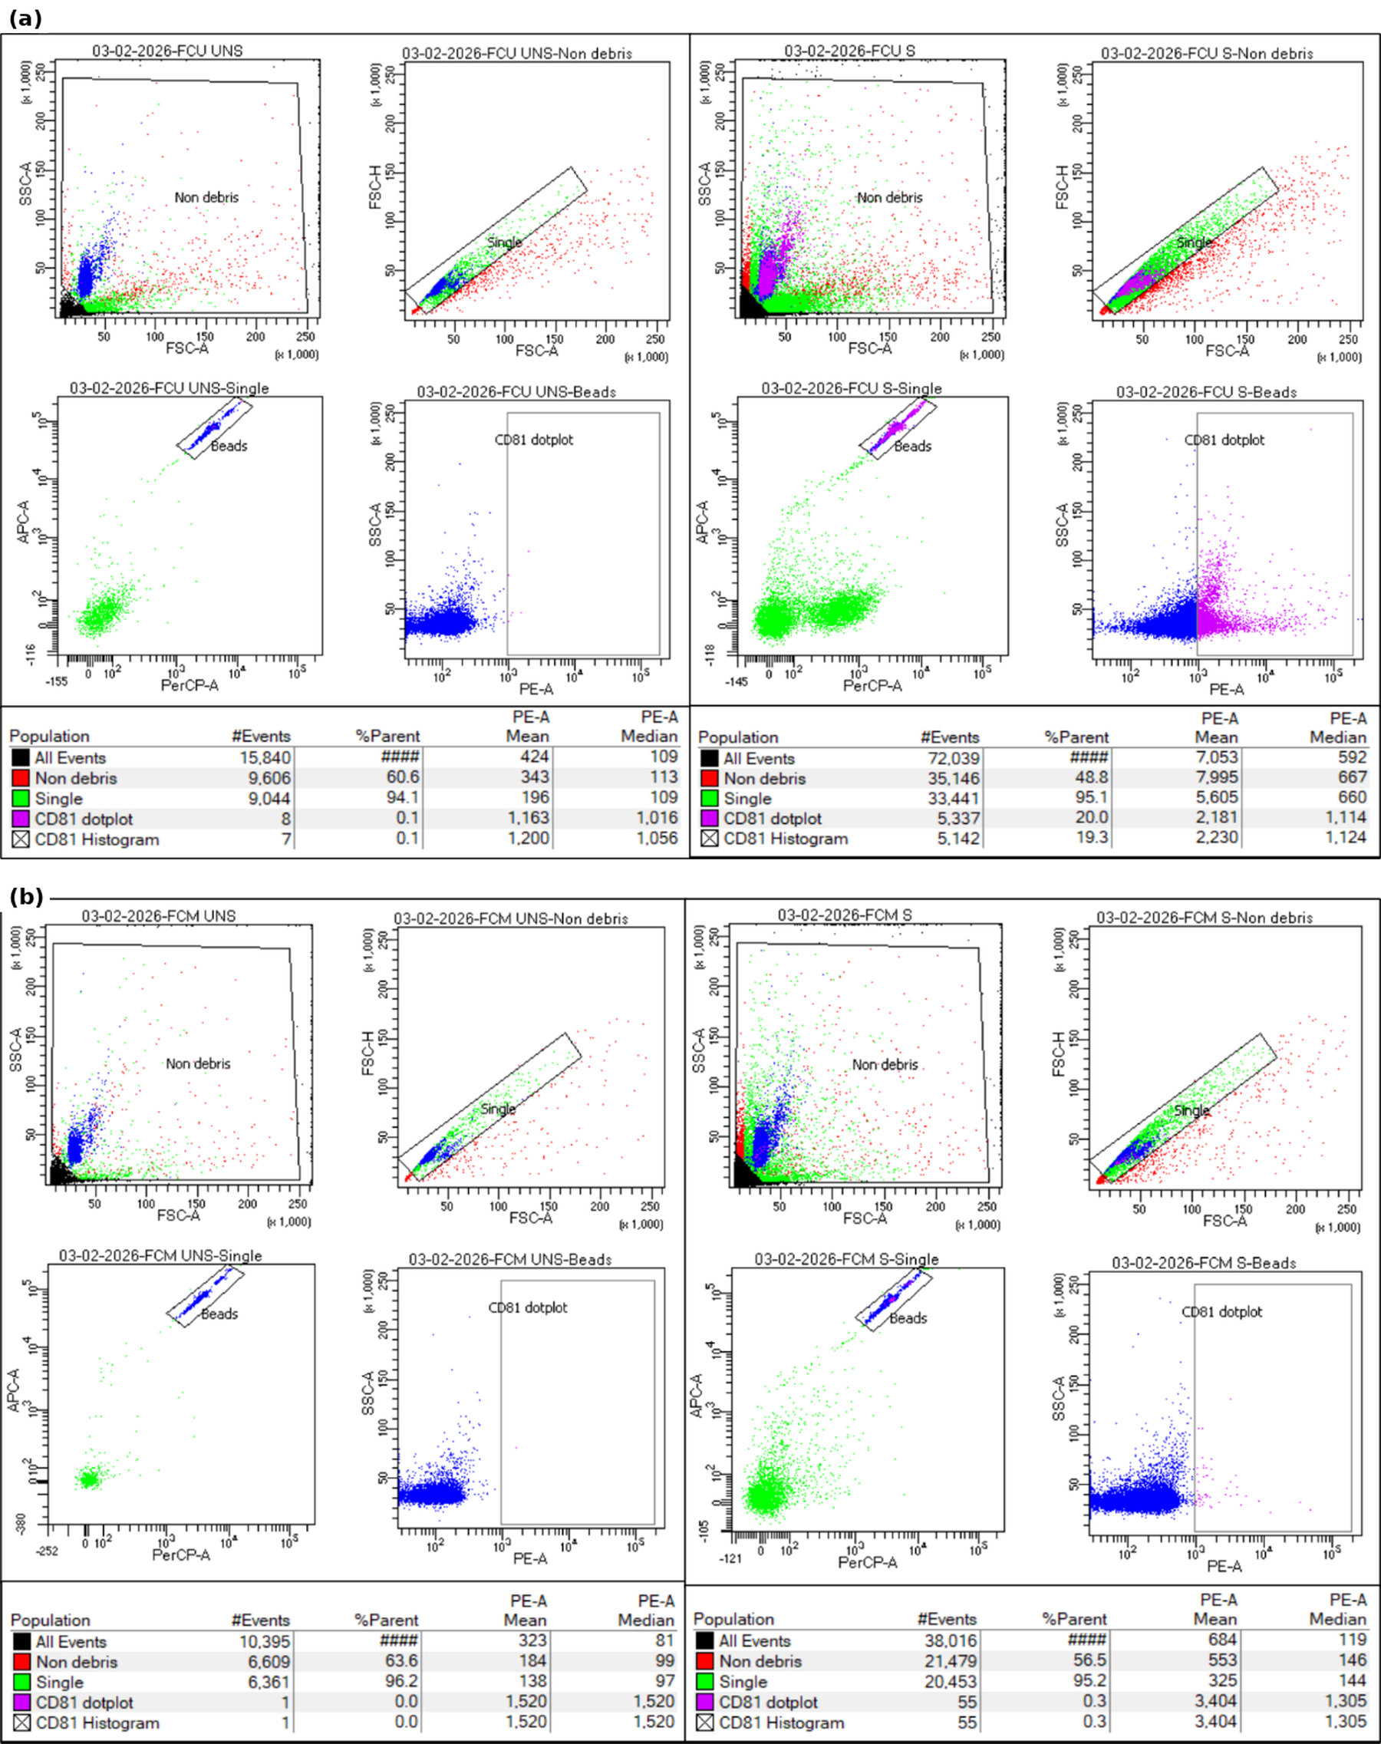
Figure 4. Representative bead-based flow-cytometry gating and anti-human CD81-PE detection in (a) urine and (b) honey preparations, comparing unstained (UNS) and stained (S) tubes. The sequence comprised non-debris gating, singlet selection, bead-event identification, and CD81 assessment. The assay is not validated as an identity test for honey-derived particles.

Cryo-electron microscopy
Cryo-EM showed rounded or ovoid membrane-enclosed vesicular structures in both preparations (Figure 5). Representative fields contained structures in the nanoscale range, with no attempt to derive a quantitative diameter distribution from the selected micrographs. These observations establish the presence of membrane-enclosed material in the preparations but do not establish particle concentration, purity, or biogenesis-based EV subtype.
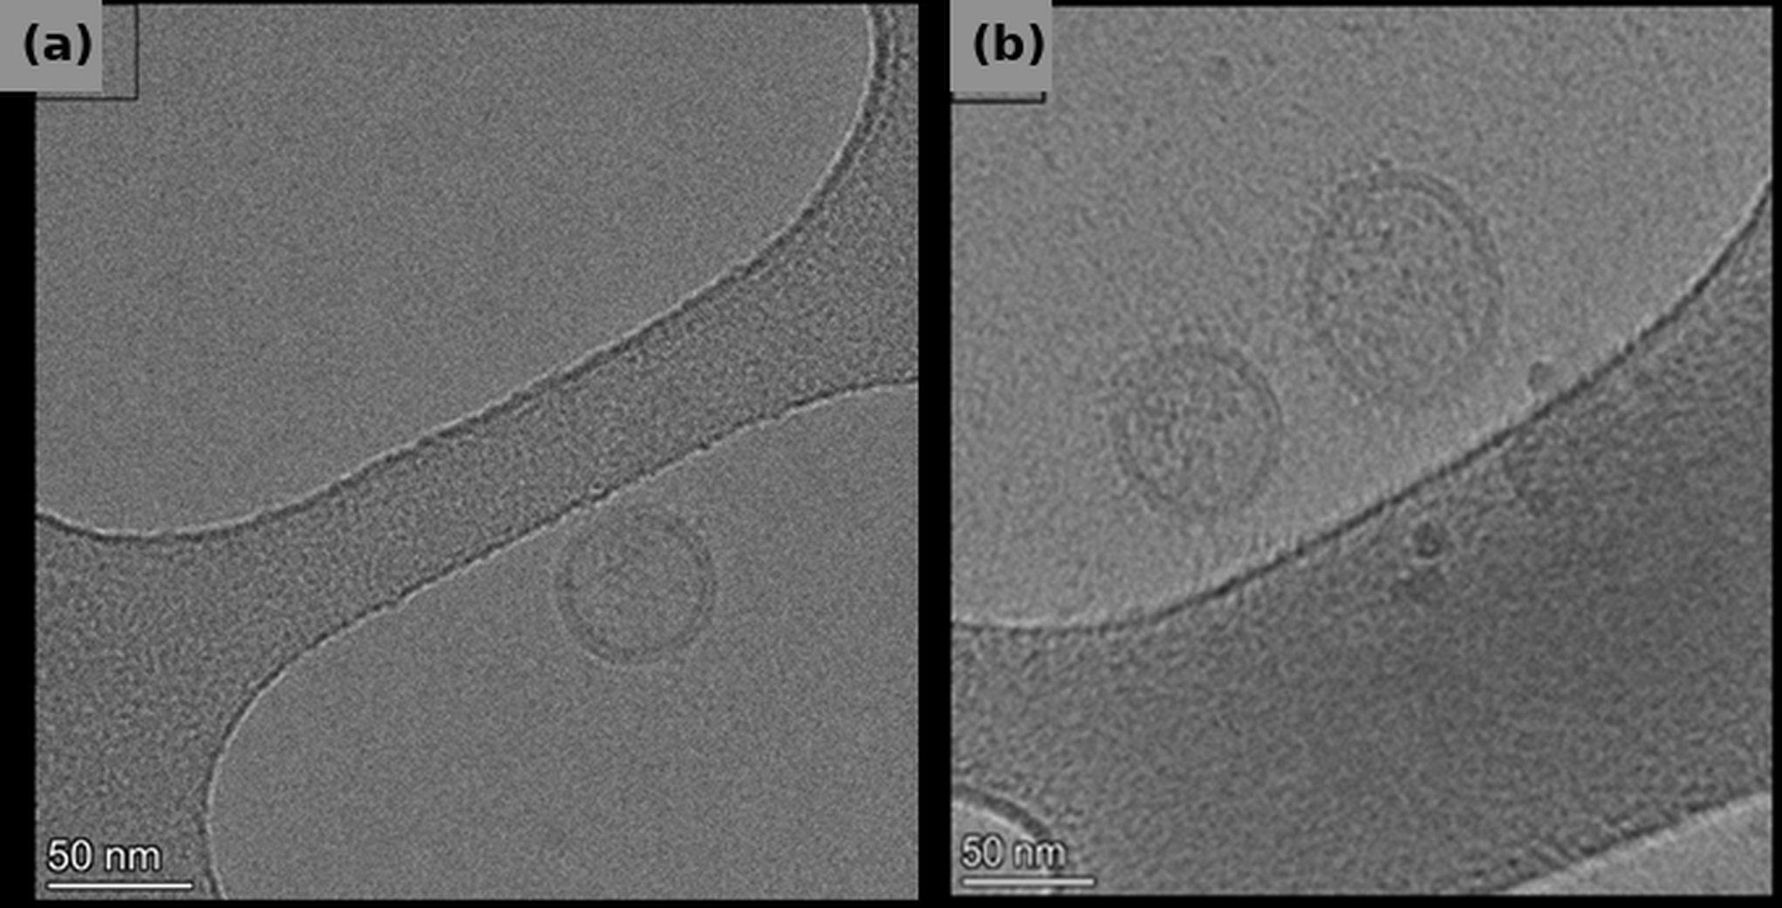
Figure 5. Representative cryo-electron micrographs of (a) honey and (b) urine preparations showing membrane-enclosed vesicular structures in vitreous ice. Scale bars = 50 nm.

DISCUSSION
The present comparison demonstrates that a common enrichment framework can recover membrane-enclosed, nanoscale-to-submicron material from both urine and honey, while also showing why matrix-specific interpretation is essential. The strongest evidence common to the two preparations was morphological: cryo-EM directly demonstrated membrane-enclosed structures. DLS and total-protein measurements complemented that evidence but could not establish EV identity or purity on their own. This interpretation follows MISEV2023 principles, which emphasize multiple orthogonal readouts and explicit acknowledgement of method-specific limitations (2).
Urine showed a broad DLS range despite a representative nanoscale peak. This is plausible for urinary preparations because concentration, storage, urinary proteins, and uromodulin can alter aggregation and recovery (6,7). DLS is also intrinsically biased toward larger scatterers, so a modest amount of aggregated or larger material can markedly shift the intensity-weighted Z-average. The reported values should therefore be read as preparation-level physical descriptors, not as the median diameter of individual vesicles. A single-particle method such as nanoparticle tracking analysis or another validated particle-counting approach would be required to obtain a particle concentration and count-based size distribution.
Honey showed a broader range of intensity-weighted DLS Z-average values than urine, extending into the submicron range. The representative honey run reported a PDI of 1.698; because this unusually high instrument output is not a dependable quantitative measure of dispersion breadth, it was not interpreted as such. The DLS findings do not negate the cryo-EM observation of membrane-enclosed nanoscale structures: larger or aggregated material may dominate intensity-weighted scattering. Prior studies have reported vesicle-like nanoparticles in honey and bee products, but such particles should be described using source-aware terminology and characterized independently of mammalian EV markers (14,16).
The zeta-potential experiment provides a further example of an analytical limitation that can otherwise be overinterpreted. Both matrices were measured in PBS with conductivity close to 16 mS/cm. Under these conditions, compression of the electrical double layer makes the near-neutral apparent values unsuitable as intrinsic surface-charge measurements. A future experiment should use a validated low-conductivity dispersant and explicitly report ionic strength, pH, conductivity, and dilution conditions.
Total protein concentrations were similar in the final urine and honey suspensions, but protein quantity cannot be equated with particle number. Urinary preparations can contain uromodulin and soluble proteins, whereas honey contains abundant non-vesicular biomolecules. Future work should pair particle counts with protein measurements and evaluate matrix-specific contaminants to estimate particle-to-protein relationships more meaningfully (2,6).
The bead-based flow-cytometry findings require particularly cautious interpretation. The urine preparation produced a clear anti-human CD81-associated signal over its unstained control, consistent with capture of human tetraspanin-bearing material; however, the method used bead capture and does not directly enumerate single EVs. The honey result cannot be interpreted with the same biological meaning. The kit uses anti-human CD9 capture and anti-human CD81 detection and was developed for human plasma. The 0.3% signal in honey is therefore best regarded as assay background or limited cross-reactivity rather than evidence for or against honey vesicle identity. Source-appropriate molecular or lipid markers are needed for honey-derived nanoparticles.
This study has several limitations. Because preparations were pooled after isolation, characterization results were available only at the pooled-matrix level rather than as independent donor- or batch-resolved biological replicates. This precluded evaluation of biological variability and inferential comparisons. Absolute particle concentration was not measured. The marker panel lacked additional transmembrane and cytosolic EV-associated proteins as well as negative or contaminant markers, and isotype, bead-only, and detergent-lysis controls were not available for flow cytometry. Cryo-EM was qualitative and did not include systematic diameter measurements. Finally, no loading, uptake, toxicity, or bioactivity assays were performed; consequently, the present data do not establish diagnostic or drug-delivery utility. These limitations define specific priorities for a subsequent validation study.
Despite these constraints, the work provides a useful descriptive comparison of two accessible but biologically distinct matrices using the same broad isolation workflow. Previous work has compared EV-enrichment methods in human serum (25). Here, the principal contribution is not demonstration of equivalence between urine and honey, but identification of how measurement interpretation changes across a human biofluid and a complex non-human natural product.

CONCLUSIONS
Urine and honey yielded enriched preparations containing membrane-enclosed vesicular structures, but their physicochemical profiles and analytical interpretability differed substantially. Urine showed a clearer anti-human CD81-associated bead signal, whereas the human tetraspanin assay was not suitable for validating honey-derived particles. DLS demonstrated marked heterogeneity, particularly in honey, and zeta-potential values obtained in high-conductivity PBS were buffer limited. The findings should therefore be regarded as a descriptive characterization baseline rather than evidence of EV purity, particle yield, biological function, or therapeutic suitability. Future studies should incorporate donor- and batch-resolved measurements, absolute particle counting, broader positive and negative marker panels, low-conductivity zeta-potential conditions, quantitative cryo-EM analysis, and source-appropriate honey markers before functional applications are evaluated.

DECLARATIONS

Ethics approval and consent to participate
The human-subject component of this study was limited to urine collection from healthy donors. The Medical and Health Research Ethics Committee, Faculty of Medicine and Health Sciences, Krida Wacana Christian University, approved the protocol “Isolation and identification of extracellular vesicles from healthy donor urine” (Approval No. 1939/SLKE/IM/UKKW/FKIK/KEPK/III/2025; 27 March 2025). Written informed consent was obtained from all urine donors before collection. The honey samples were commercial non-human materials; the approval is not represented as covering experiments on honey.

Consent for publication
Not applicable; this report contains no identifying individual participant information or images.

Availability of data and materials
The data supporting the findings of this study, including original instrument outputs, are retained by the authors and can be provided to the journal editors by the corresponding author upon request. The summary-level results are presented in this article, Tables 1-4, and Figures 1-5.

Competing interests
The authors declare that they have no competing interests.

Funding
This work was supported by the Ministry of Higher Education, Science and Technology of the Republic of Indonesia through the BIMA Fundamental Research Grant (Decree No. 0419/C3/DT.05.00/2025).

Role of the funding body
The funding body had no role in the study design.

Authors' contributions
Agus Limanto: Conceptualization, Supervision, Writing – review & editing. Glen Marchelinno Souissa: Investigation, Data curation, Writing – original draft. Bryan Christopher Wiraputra: Investigation, Data curation, Writing – original draft. Deby Deby: Methodology, Formal analysis, Writing – review & editing. Purnamawati: Supervision, Validation, Writing – review & editing. Eden Steven: Methodology, Resources, Visualization. Yudhi Nugraha: Methodology, Validation, Writing – review & editing. Ahmad Novi Muslimin: Investigation, Visualization, Data curation. All authors have reviewed and approved the contributions stated above.

Declaration of generative AI and AI-assisted technologies in the writing process
OpenAI ChatGPT (GPT-5.6 Sol) assisted with English-language editing, abstract restructuring, reference citation formatting, and document layout. No experimental data, microscopy images, or research datasets were generated using AI. The scope of assistance is also described in Materials and Methods.

LIST OF ABBREVIATIONS
CD9/CD81: cluster of differentiation 9/81
cryo-EM: cryo-electron microscopy
DLS: dynamic light scattering
EV: extracellular vesicle
PBS: phosphate-buffered saline
PDI: polydispersity index

REFERENCES
1. Théry C, Witwer KW, Aikawa E, Alcaraz MJ, Anderson JD, Andriantsitohaina R, et al. Minimal information for studies of extracellular vesicles 2018 (MISEV2018): A position statement of the International Society for Extracellular Vesicles and update of the MISEV2014 guidelines. J Extracell Vesicles 2018;7(1):1535750. doi:10.1080/20013078.2018.1535750.
2. Welsh JA, Goberdhan DCI, O'Driscoll L, Buzas EI, Blenkiron C, Bussolati B, et al. Minimal information for studies of extracellular vesicles (MISEV2023): From basic to advanced approaches. J Extracell Vesicles 2024;13(2):e12404. doi:10.1002/jev2.12404.
3. Pisitkun T, Shen RF, Knepper MA. Identification and proteomic profiling of exosomes in human urine. Proc Natl Acad Sci U S A 2004;101(36):13368-13373. doi:10.1073/pnas.0403453101.
4. Gonzales PA, Pisitkun T, Hoffert JD, Tchapyjnikov D, Star RA, Kleta R, et al. Large-scale proteomics and phosphoproteomics of urinary exosomes. J Am Soc Nephrol 2009;20(2):363-379. doi:10.1681/ASN.2008040406.
5. Oosthuyzen W, Sime NEL, Ivy JR, Turtle EJ, Street JM, Pound J, et al. Quantification of human urinary exosomes by nanoparticle tracking analysis. J Physiol 2013;591(23):5833-5842. doi:10.1113/jphysiol.2013.264069.
6. Erdbrügger U, Blijdorp CJ, Bijnsdorp IV, Borràs FE, Burger D, Bussolati B, et al. Urinary extracellular vesicles: A position paper by the Urine Task Force of the International Society for Extracellular Vesicles. J Extracell Vesicles 2021;10(7):e12093. doi:10.1002/jev2.12093.
7. Wang Y, Zhang M. Urinary exosomes: A promising biomarker for disease diagnosis. Lab Med 2023;54(2):115-125. doi:10.1093/labmed/lmac087.
8. Zhou H, Yuen PST, Pisitkun T, Gonzales PA, Yasuda H, Dear JW, et al. Collection, storage, preservation, and normalization of human urinary exosomes for biomarker discovery. Kidney Int 2006;69(8):1471-1476. doi:10.1038/sj.ki.5000273.
9. Kosanović M, Janković M. Isolation of urinary extracellular vesicles from Tamm-Horsfall protein-depleted urine and their application in the development of a lectin-exosome-binding assay. Biotechniques 2014;57(3):143-149. doi:10.2144/000114208.
10. Musante L, Bontha SV, La Salvia S, Fernandez-Piñeros A, Lannigan J, Le TH, et al. Rigorous characterization of urinary extracellular vesicles (uEVs) in the low centrifugation pellet - a neglected source for uEVs. Sci Rep 2020;10(1):3701. doi:10.1038/s41598-020-60619-w.
11. Mu J, Zhuang X, Wang Q, Jiang H, Deng ZB, Wang B, et al. Interspecies communication between plant and mouse gut host cells through edible plant derived exosome-like nanoparticles. Mol Nutr Food Res 2014;58(7):1561-1573. doi:10.1002/mnfr.201300729.
12. Zhuang X, Deng ZB, Mu J, Zhang L, Yan J, Miller D, et al. Ginger-derived nanoparticles protect against alcohol-induced liver damage. J Extracell Vesicles 2015;4:28713. doi:10.3402/jev.v4.28713.
13. Zhang M, Viennois E, Prasad M, Zhang Y, Wang L, Zhang Z, et al. Edible ginger-derived nanoparticles: A novel therapeutic approach for the prevention and treatment of inflammatory bowel disease and colitis-associated cancer. Biomaterials 2016;101:321-340. doi:10.1016/j.biomaterials.2016.06.018.
14. Schuh CMAP, Aguayo S, Zavala G, Khoury M. Exosome-like vesicles in Apis mellifera bee pollen, honey and royal jelly contribute to their antibacterial and pro-regenerative activity. J Exp Biol 2019;222(20):jeb208702. doi:10.1242/jeb.208702.
15. Sundaram K, Miller DP, Kumar A, Teng Y, Sayed M, Mu J, et al. Plant-derived exosomal nanoparticles inhibit pathogenicity of Porphyromonas gingivalis. iScience 2019;21:308-327. doi:10.1016/j.isci.2019.10.032.
16. Chen X, Liu B, Li X, An TT, Zhou Y, Li G, et al. Identification of anti-inflammatory vesicle-like nanoparticles in honey. J Extracell Vesicles 2021;10(4):e12069. doi:10.1002/jev2.12069.
17. Dad HA, Gu TW, Zhu AQ, Huang LQ, Peng LH. Plant exosome-like nanovesicles: Emerging therapeutics and drug delivery nanoplatforms. Mol Ther 2021;29(1):13-31. doi:10.1016/j.ymthe.2020.11.030.
18. Dragovic RA, Gardiner C, Brooks AS, Tannetta DS, Ferguson DJP, Hole P, et al. Sizing and phenotyping of cellular vesicles using nanoparticle tracking analysis. Nanomedicine 2011;7(6):780-788. doi:10.1016/j.nano.2011.04.003.
19. van der Pol E, Coumans FAW, Grootemaat AE, Gardiner C, Sargent IL, Harrison P, et al. Particle size distribution of exosomes and microvesicles determined by transmission electron microscopy, flow cytometry, nanoparticle tracking analysis, and resistive pulse sensing. J Thromb Haemost 2014;12(7):1182-1192. doi:10.1111/jth.12602.
20. Stetefeld J, McKenna SA, Patel TR. Dynamic light scattering: A practical guide and applications in biomedical sciences. Biophys Rev 2016;8(4):409-427. doi:10.1007/s12551-016-0218-6.
21. Welsh JA, van der Pol E, Arkesteijn GJA, Bremer M, Brisson A, Coumans F, et al. MIFlowCyt-EV: A framework for standardized reporting of extracellular vesicle flow cytometry experiments. J Extracell Vesicles 2020;9(1):1713526. doi:10.1080/20013078.2020.1713526.
22. Yuana Y, Koning RI, Kuil ME, Rensen PCNM, Koster AJ, Bertina RM, et al. Cryo-electron microscopy of extracellular vesicles in fresh plasma. J Extracell Vesicles 2013;2:21494. doi:10.3402/jev.v2i0.21494.
23. Rikkert LG, Nieuwland R, Terstappen LWMM, Coumans FAW. Quality of extracellular vesicle images by transmission electron microscopy is operator and protocol dependent. J Extracell Vesicles 2019;8(1):1555419. doi:10.1080/20013078.2018.1555419.
24. Emelyanov A, Shtam T, Kamyshinsky R, Garaeva L, Verlov N, Miliukhina I, et al. Cryo-electron microscopy of extracellular vesicles from cerebrospinal fluid. PLoS One 2020;15(1):e0227949. doi:10.1371/journal.pone.0227949.
25. Sou YL, Tan PPS, Muhamad Hendiri NA, Ratnam W, Karupaiah T, Chilian WM, et al. Evaluation of small extracellular vesicles isolation methods from human serum for downstream miRNA profiling. Malays Appl Biol 2025;54(1):98-107. doi:10.55230/mabjournal.v54i1.3357.

